The Code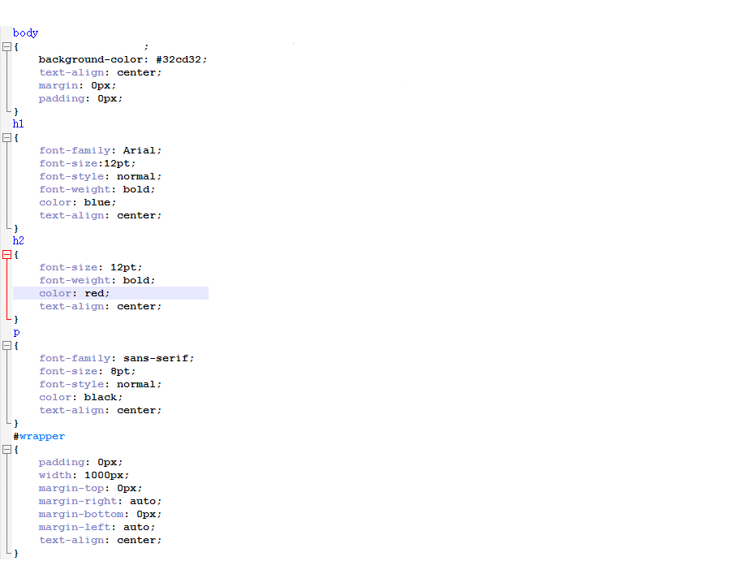

Body this controls the background by choosing what colour, design or image